Module 11 – EOQ

Exploratory Data Analysis

*In this section, you should perform some data analysis on the data provided to you. Please format your findings in a visually pleasing way and please be sure to include these cuts:*

* *Make line graphs showing the following data over time:*
  + *Sales*
  + *Unit Purchase Cost*
  + *Fixed Order Cost*
* A graph on a white sheet

  AI-generated content may be incorrect.
* A screenshot of a graph

  AI-generated content may be incorrect.
* A screenshot of a graph

  AI-generated content may be incorrect.
* *Use a forecast method to determine annual demand for 2025 to use for our model*
  + *Naïve*
  + *Moving Average / Weighted Moving Average*
  + *Linear Regression*
  + *Exponential Smoothing*
* *For costs, use a similar/different method. Otherwise, a simple overall average is fine.*

I used naïve to determine the annual demand for 2025.

Model Formulation

*Write the formulation of the model into here prior to implementing it in your Excel model. Be explicit with the definition of the decision variables, objective function, and constraints. Please restate the variables in the algorithm (i.e. D = Annual Demand)*

*D= annual demand*

*C=unit purchase cost for the item*

*S=fixed cost of placing an order*

*i=cost of holding inventory for year*

*Q= order quantity*

*Decision variables: Q=* order quantity

Objective function: MIN the Total cost

Constraints:

Q>0

Model Optimized for Minimizing Costs with Optimal Order Quantity

*Implement your formulation into Excel and be sure to make it neat. This section should include:*

* *A screenshot of your optimized final model (formatted nicely, of course)*
* *A text explanation of what your model is recommending*
* *Make a “sawtooth chart” for 2025, see below for reference. Assume you start with year with your EOQ Quantity like it has below*

**

**

My model is recommending to order 818 units each time you place an ordere.

Placing around 18 order per year.

This is an order to minimize the total relevant cost under demand being constant, and do not have any backorder.

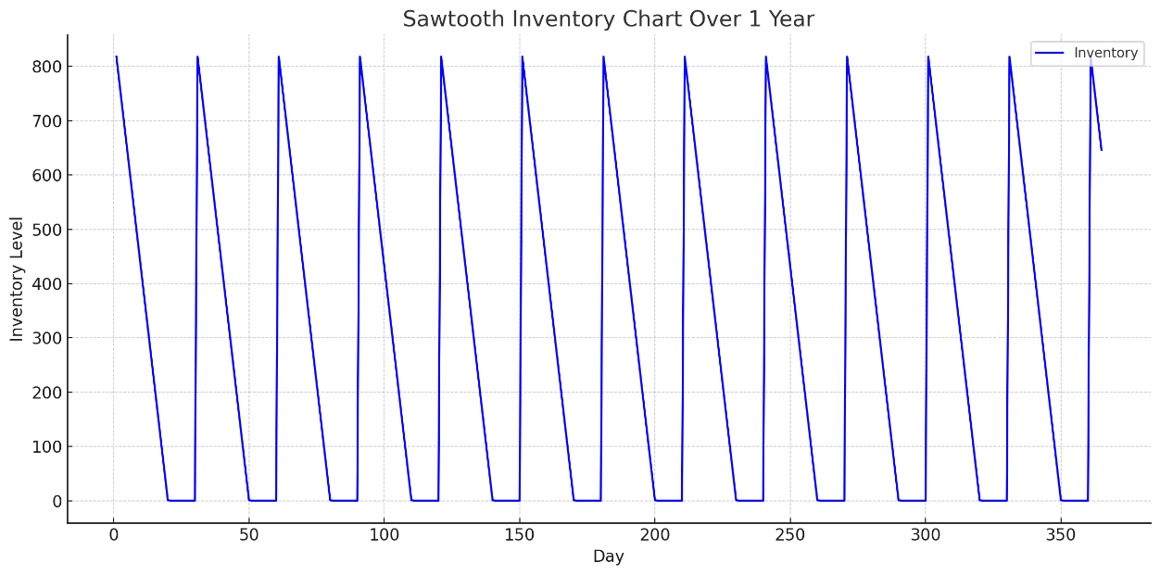

Model with Stipulation

*Please copy the tab of your original model before continuing with the next part to avoid messing up your original solution.*

*Implement the below EOQ extension, EOQ with planned backorders. We have added 2 new variables: A = shortage cost & b = planned back orders. Restate the previous variables with these new ones please. Note, you’ll need to solve for both Q\* and b\* here to get the optimal solution. You should start Q out as the EOQ from the previous section and b as 0. Also, note that this algorithm does not include `D \* C` as it’s not relevant to this analysis*

**

**

*Lastly, do the following:*

* *Explain why you may include planned backorders (i.e. plan to accept purchases when out-of-stock such that some customers will wait for their purchase). Please think critically prior to doing any searches for why*
* *Make a similar “sawtooth chart” with the results here. Note, it will be very similar as before, but inventory will go below 0 before replenishing*
* You may include planned backorders because it can reduce total cost, depending on customer and business logistics where it can lower inventory holding cost, lower order frequency, and gives more leeway in case of any demand spikes or supply chain kinks.

